Product (4 Category)
- Packaging Machinery
- Packaging Materials
- Industrial Heaters & Control Panel
- Industrial Ovens & Furnace

Packaging Machinery

Hand Operated Sealing Machine
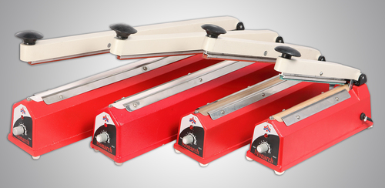
Foot Operated Sealing Machines
Foot Operated [Box Type] Foot Operated [Open Type] Foot Operated Vertical
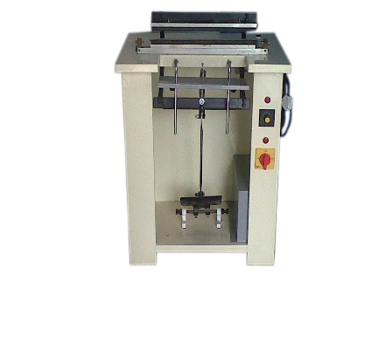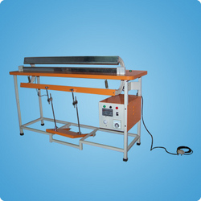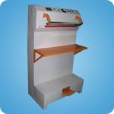

Motorized Sealing Machine Pneumatic Sealing Machine
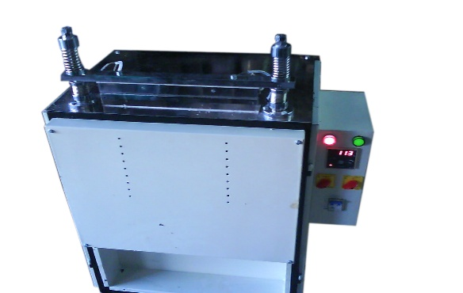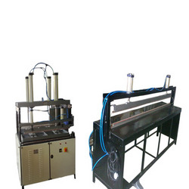

Manual Foil Sealer Machine Cup Sealer Machine Semi Auto Cup Sealer Machine
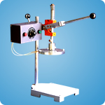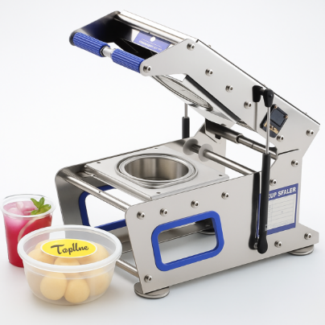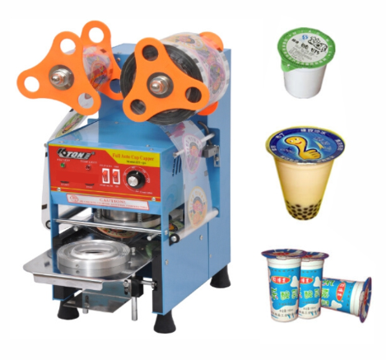

Tray Sealer Machine
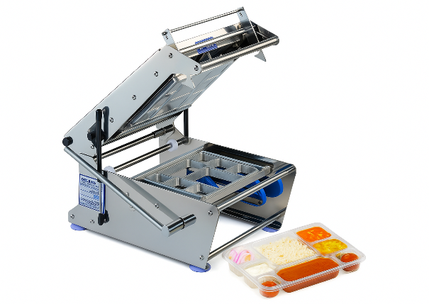
Induction Sealing Machine
Manual Portable Induction Sealer Continues Induction Sealer
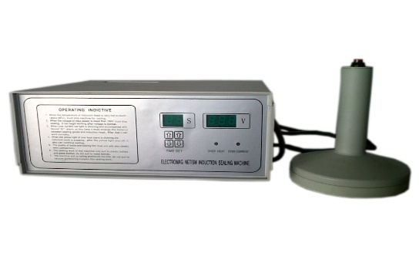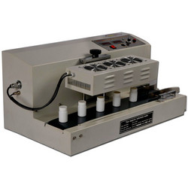

Continues Band Sealer Machine
Horizontal Model (M.S & S.S Body) Vertical Model (M.S & S.S Body) 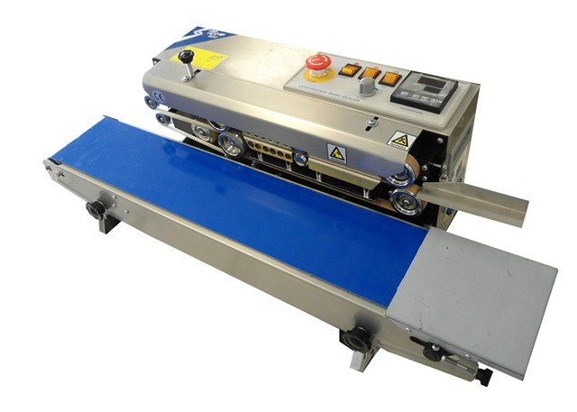 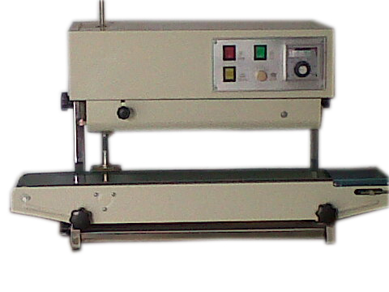

Shrink Tunnel Machine
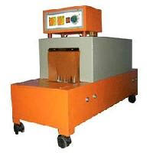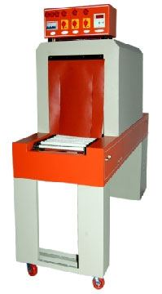

Automatic Web Sealer Shrink Tunnel Machine
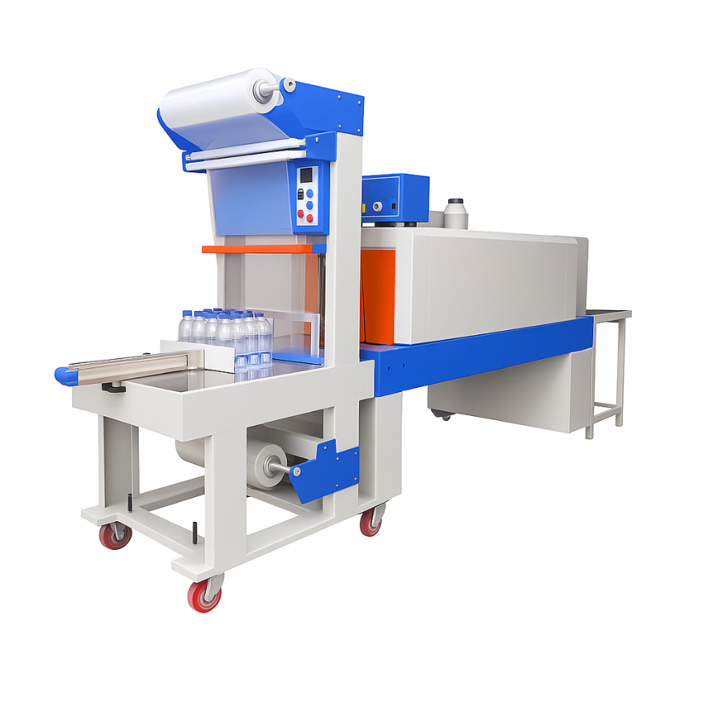
Manual L Sealer Machine Fully Auto L Sealer Machine
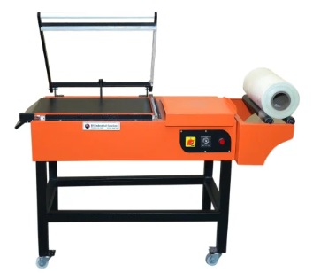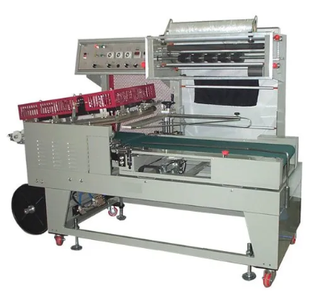
Automatic L Sealer with Shrink Tunnel Machine

Vacuum Packing Machine
DZ260 Table Top Vacuum Packing Machine DZ400 Vacuum DZ500 Vacuum
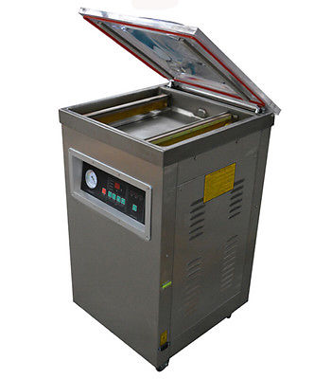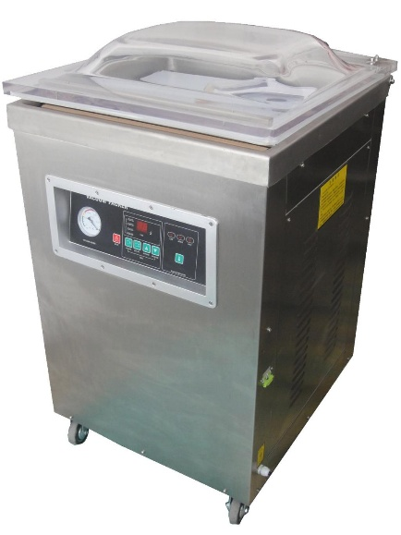

Double Chamber Vacuum Packing Machine
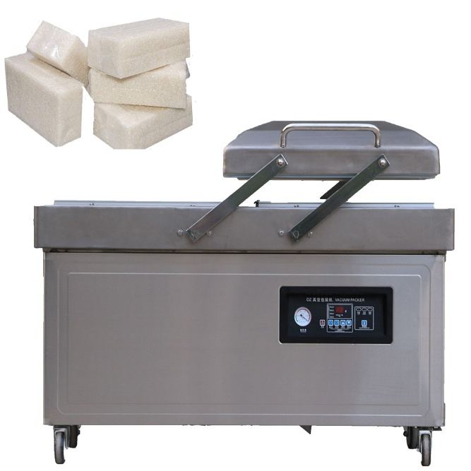
Box Strapping Machine
Semi-Automatic Box Strapping Machine Fully Auto Box Strapping Machine
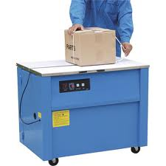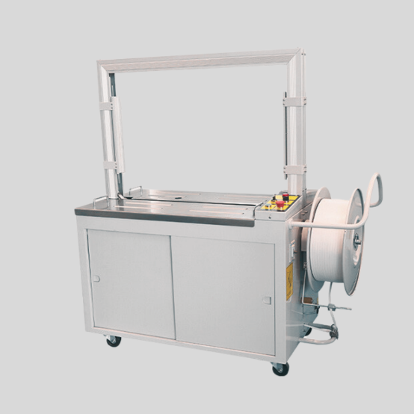

Cartoon Sealer Machine
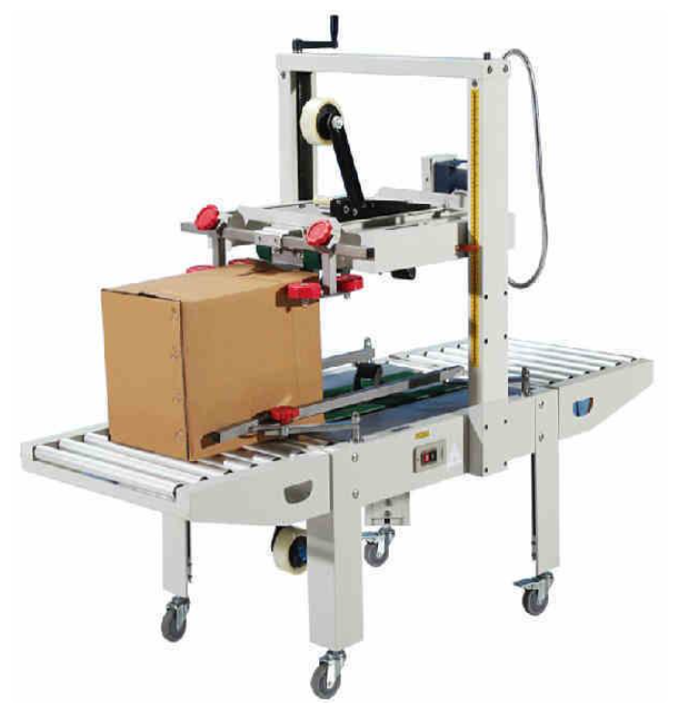
Semi-Automatic Box Stretch Wrapping Machine
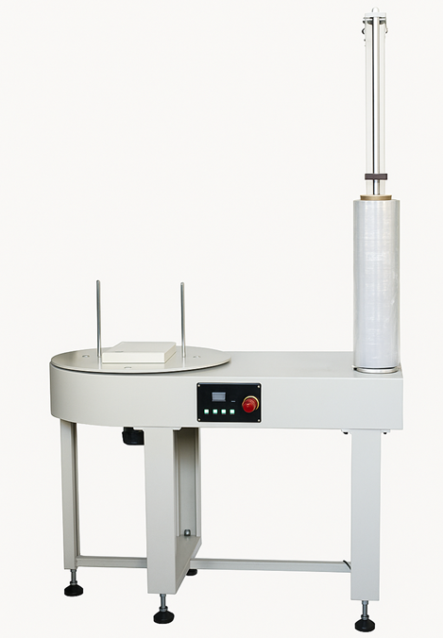
Automatic Pallet Stretch Wrapping Machine
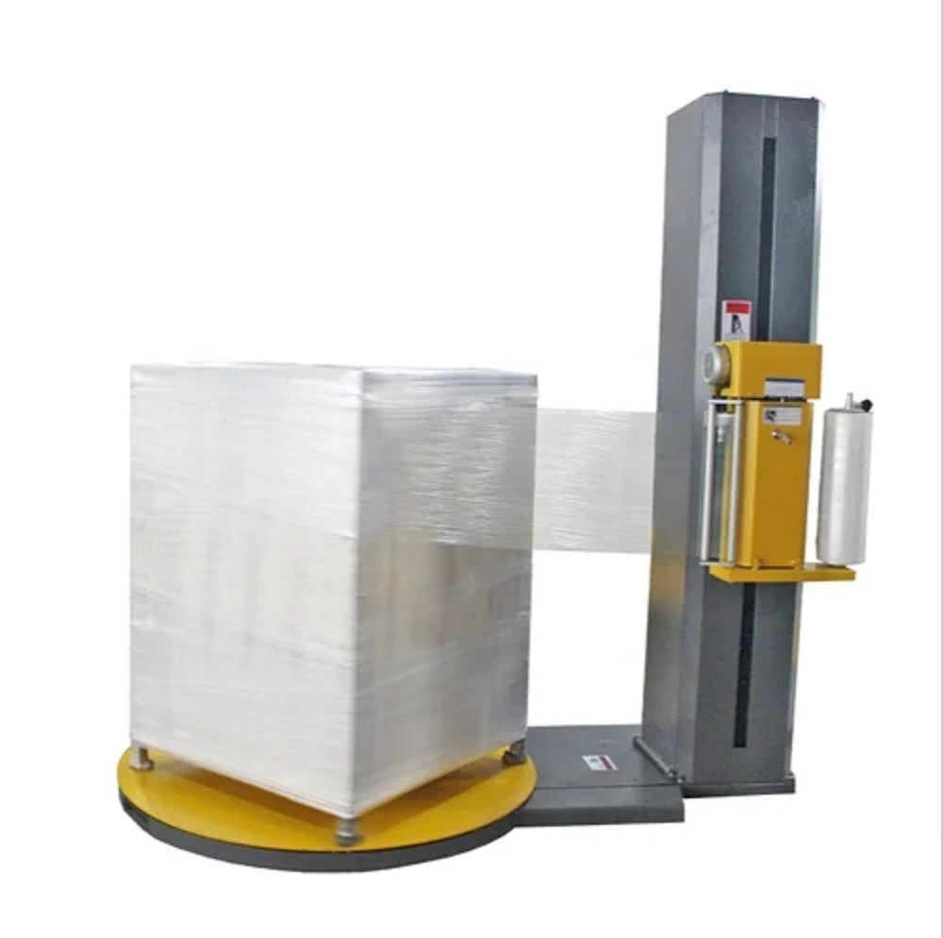

Filling Machines

Manual Filling Machine
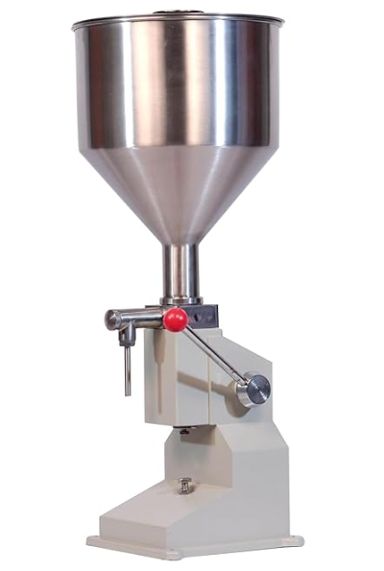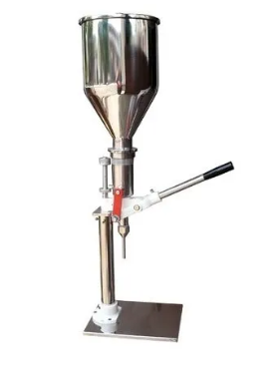

Semi Auto Filling Machine
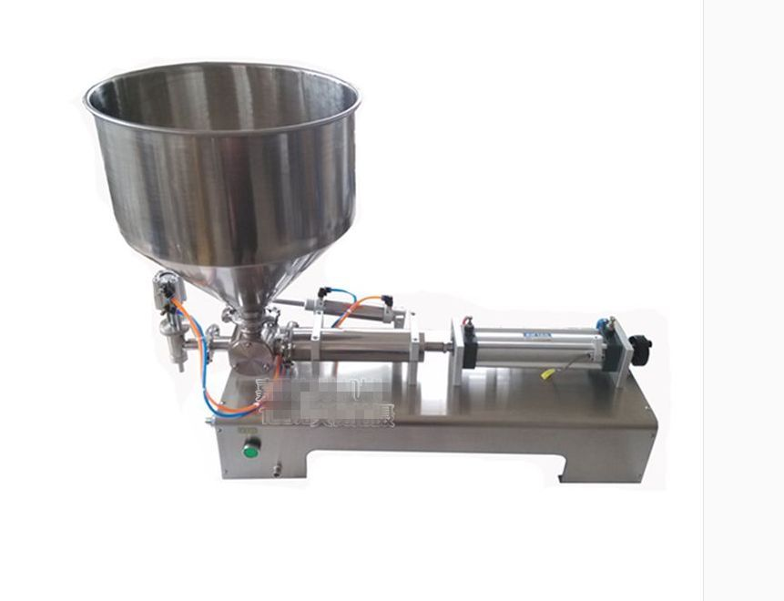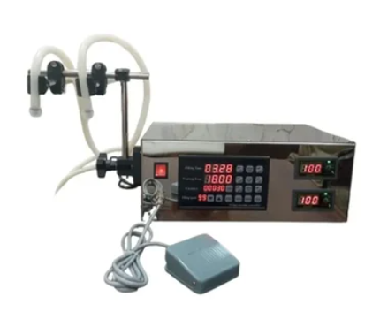

Augar Filler Machine Semi Auto Augar Filler Machine
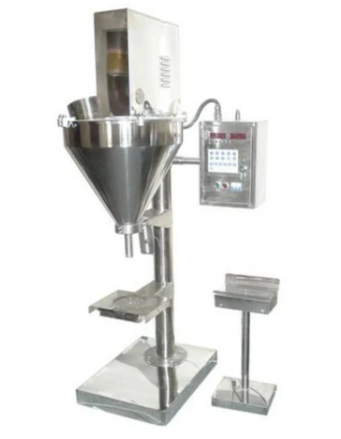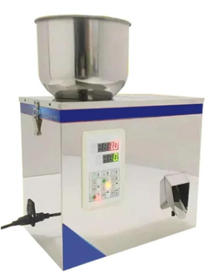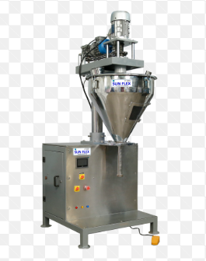

Automatic Augar Filler Machine
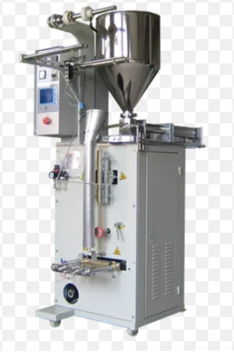

Automatic Pouch Packing Machines
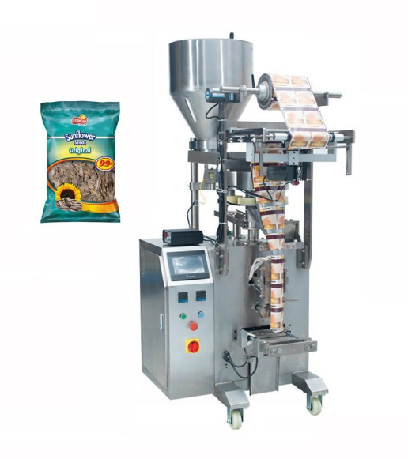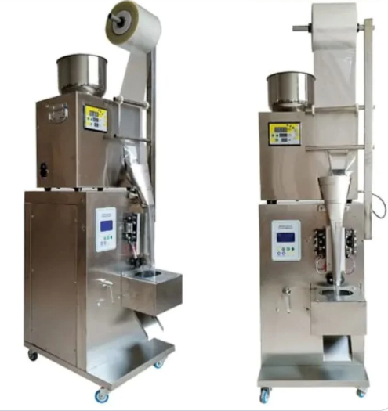
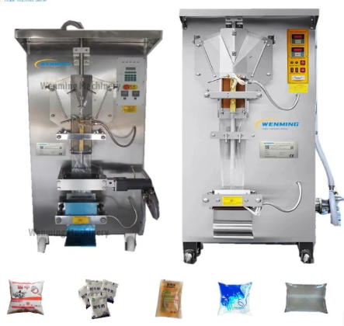

Industrial Heaters, Control Panels
& Industrial Ovens & Furnace
Heaters: All Types Industrial Heaters
Strip Heaters, Tubular Heaters, Coil Heaters, U-Type Heaters, Flange Heaters, Immersion Heaters, Cartridge Heaters, Ceramic Band Heaters, Manifold Heaters, Nozzle Heaters, Allu. Dia Cast Heaters, Infrared Heaters, Ceramic IR Heaters and etc.
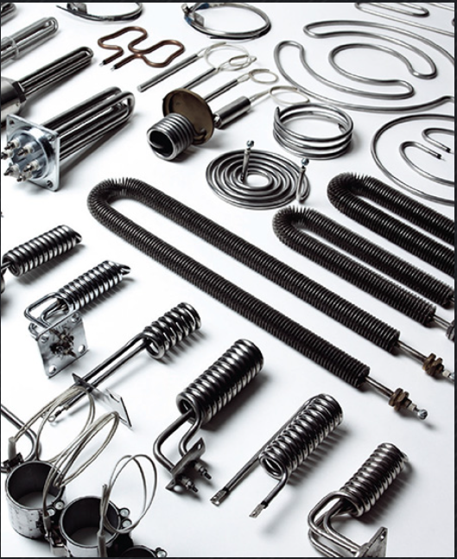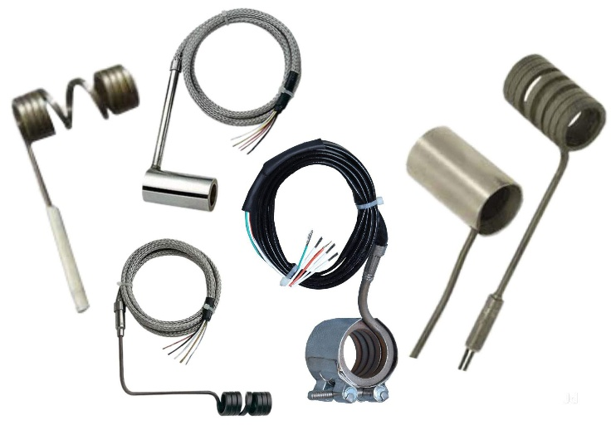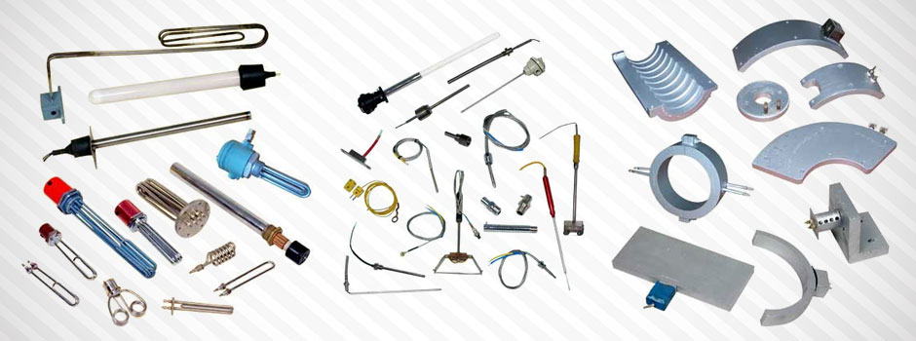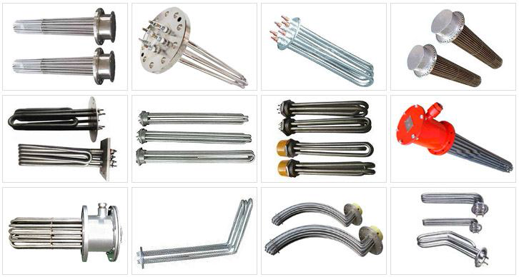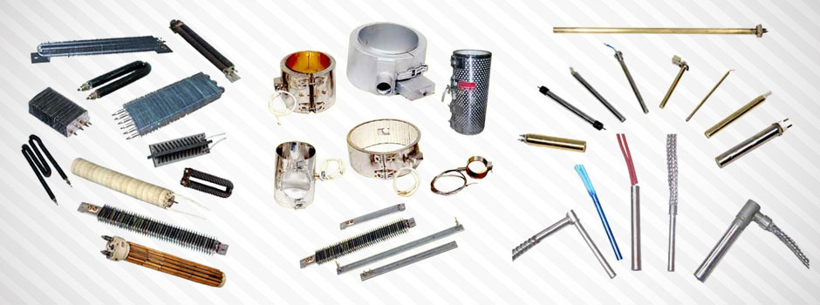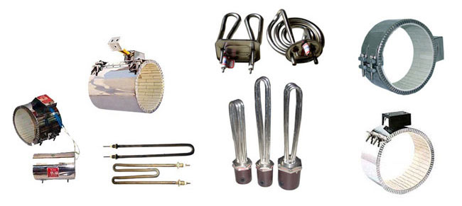
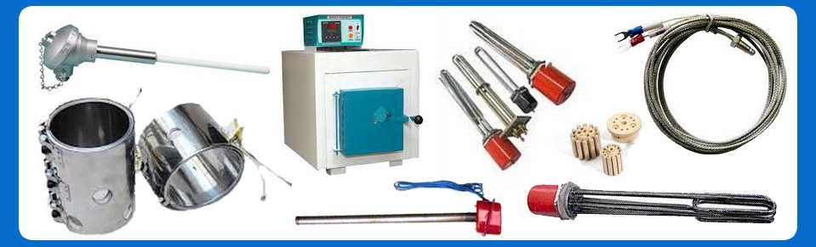
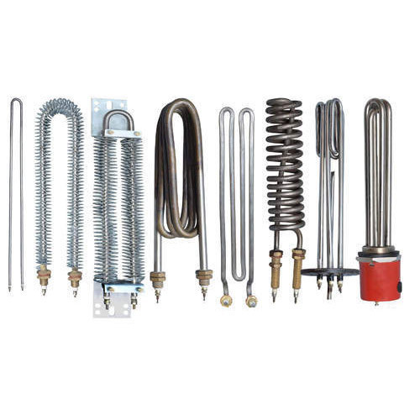

Thermocouple Sensors
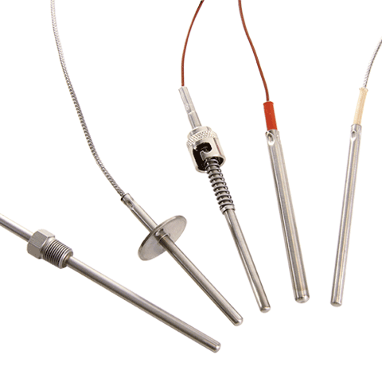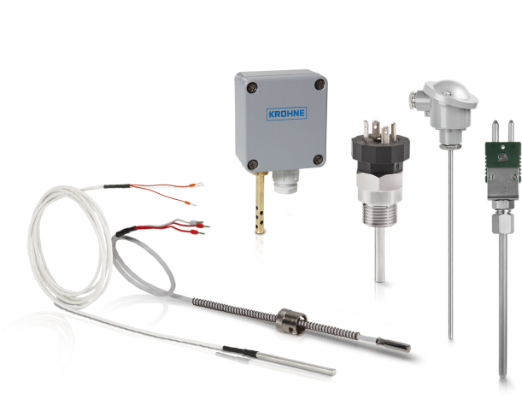
Sensors: All Types Sensors
Thermocouple (J, K, T, E, N - Types), Resistance Temperature Detectors (RTDs), Negative Temperature Coefficient (NTC) Thermistors, and many more.
Control Panels
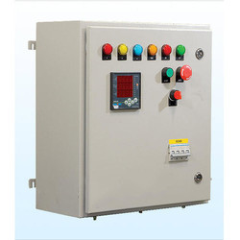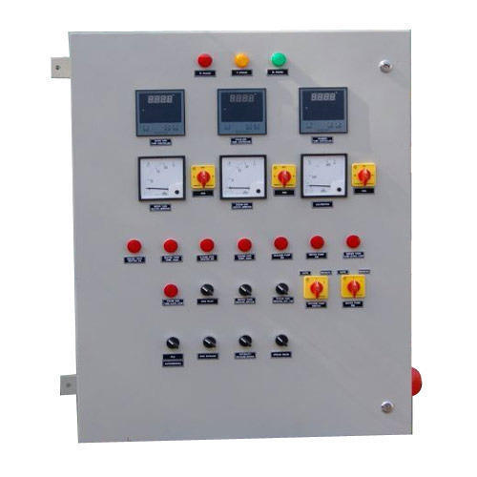

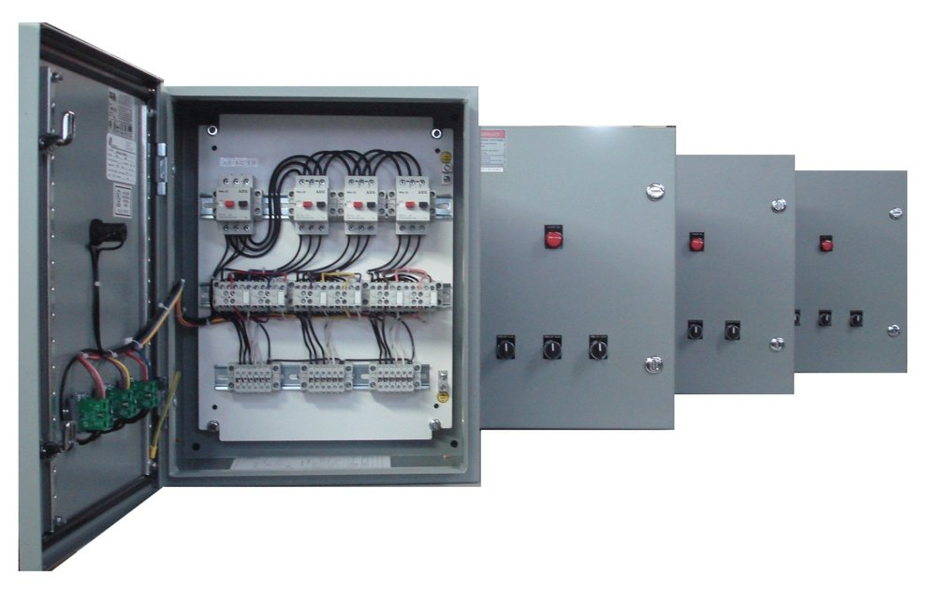
Industrial Ovens & Furnace
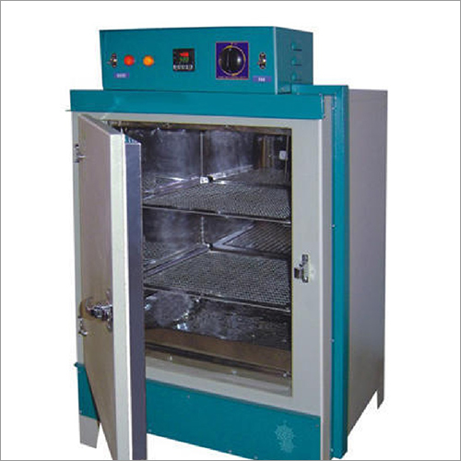
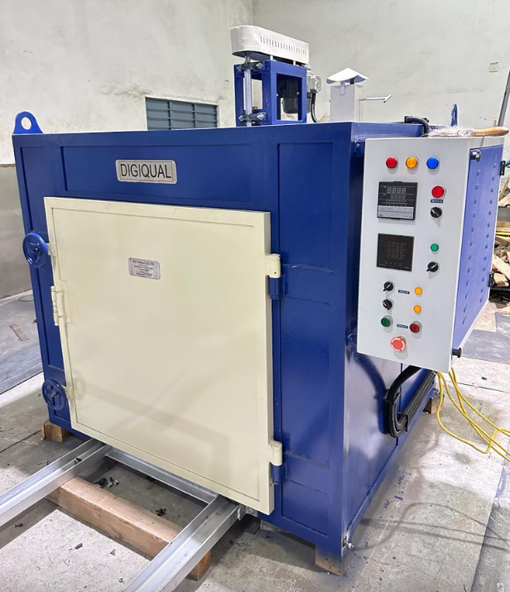
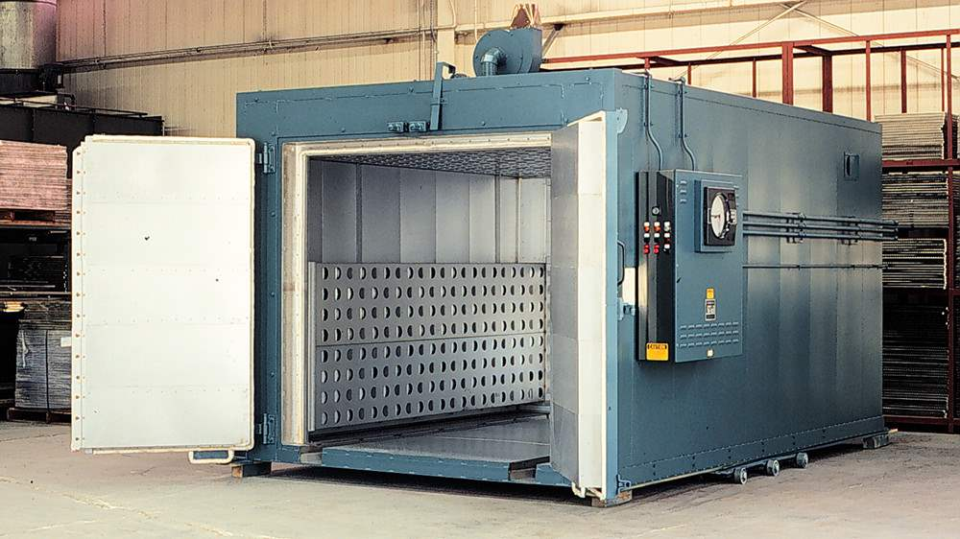

Packaging Machinery
Materials: All Types Packaging Materials
Shrink Film (PVC, LDPE, POF), Stretch Film, Bubble Films, Tarpaulin Films,
Cartoon Sealing Tapes (Clear & Colored), Packaging Pouches, Vacuum Pouches, Lidding Films, Strapping Rolls, Pet Strapping Rolls and many more.